Ping from 10.0.0.10 to 40.0.0.10
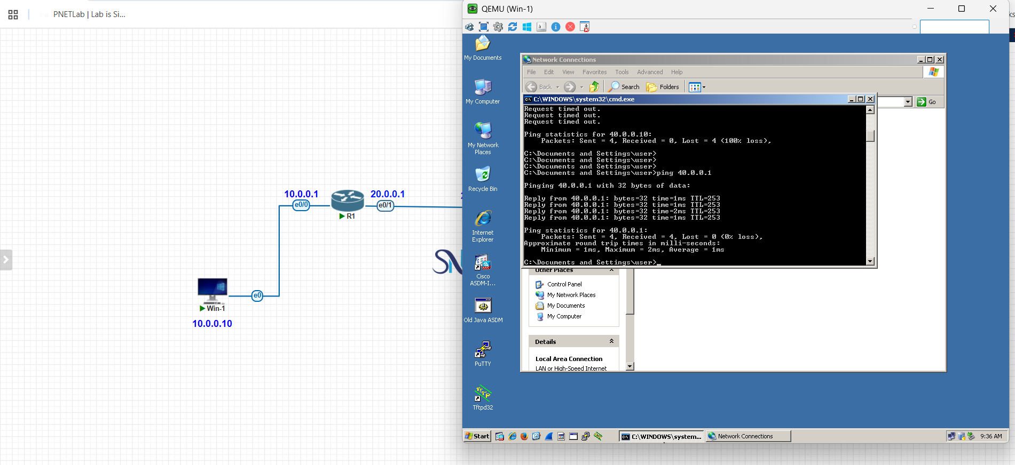

Ping from 40.0.0.10 to 10.0.0.10

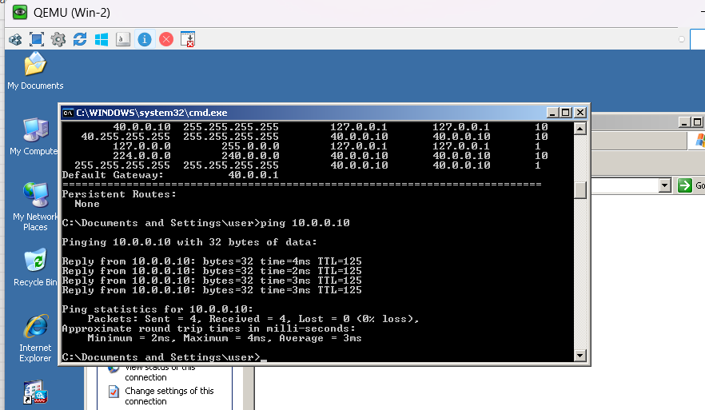

R1 – Static route
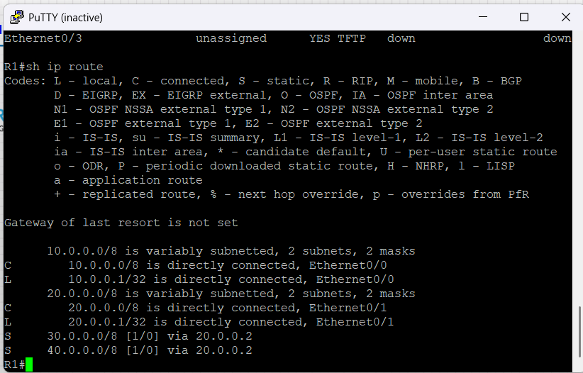

R2 – Static route

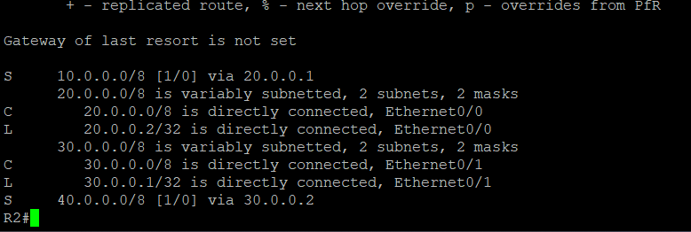

R3- Static route

